Republic of Croatia
Ministry of Justice
Directorate for Strategic Development, Informatization
and Capital Investments in Judiciary

STAKEHOLDER ENGAGEMENT PLAN
JUSTICE FOR BUSINESS PROJECT

ENERGY RENEWAL, RENOVATION, ADAPTATION AND UPGRADE OF SELECTED JUDICIAL BUILDINGS:
County Court in Varaždin, Municipal Courts in Kutina, Vinkovci and Zagreb

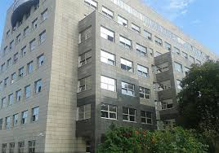

November 2019

ABBREVIATIONS

AC Administrative Court
BM Bank Management
CO Conservation Office
ESCP Environmental and Social Commitment Plan
ESF Environmental and Social Framework
ESMP Environmental and Social Management Plan
GRM Grievance Redress Mechanism
GRS Grievance Redress Service
IP Inspection Panel
IPF Investment Project Financing
JUST-B Justice for Business Project
MOC Ministry of Culture of the Republic of Croatia
MOJ Ministry of Justice of the Republic of Croatia
OG Official Gazette
PIU Project Implementation Unit
PM Project Manager
PP Public Procurement
SEP Stakeholder Engagement Plan
WB World Bank

TABLE OF CONTENTS

INTRODUCTION AND PROJECT DESCRIPTION 1
Energy renewal and renovation of the Municipal Court in Kutina 3
Renovation, adaptation and upgrade of the County Court in Varaždin 3
Renovation and adaptation of the Municipal Court in Vinkovci 4
Renovation and adaptation of the Municipal Court in Zagreb 4
POTENTIAL ENVIRONMENTAL AND SOCIAL RISKS
AND IMPACTS OF CIVIL WORKS 6
Environmental risk and impact 6
Social risk and impact 6
BRIEF SUMMARY OF PREVIOUS
STAKEHOLDER ENGAGEMENT ACTIVITIES TO DATE 7
STAKEHOLDER IDENTIFICATION AND ANALYSIS 7
Stakeholder identification 7
STAKEHOLDER ENGAGEMENT PROGRAM 12
Purpose and timing of stakeholder engagement program 12
RESOURCES AND RESPONSIBILITIES FOR
IMPLEMENTING STAKEHOLDER ENGAGEMENT ACTIVITIES 14
INFORMATION DISCLOSURE 15
Consultation schedule 16
MONITORING AND REPORTING 17
GRIEVANCE REDRESS MECHANISM 18
Objectives of the project-based GRM 18
GRM overview and structure 18
GRM scope and use 19
MoJ’s complaint mechanisms practice 19
WB’s complaint mechanisms practice 20
Complaints management and dispute resolution systems within public procurement 21
CONCLUSIONS 23

INTRODUCTION AND PROJECT DESCRIPTION
The Justice for Business Project (JUST-B) aims to contribute to the establishment of a judicial system that will meet the highest European standards in terms of independence, impartiality, expertise and efficiency, thereby justifying the confidence of citizens and contributing to the progress of society. Within Component I: Investment Project Financing (IPF), the following sub-components will be financed:
a) the rehabilitation and/or reconstruction of courts physical infrastructure in Zagreb Municipal Court, and judicial facilities in Vinkovci, Kutina and Varaždin;
b) the preparation of detailed design for the project facilities, civil work supervision, and technical building audits.
The objective of project is to improve the working conditions of selected judicial bodies, make them more energy efficient, functional in line with the Ministry of Justice (MoJ) vision of a modern and efficient judiciary system. The project will support energy renewal, renovation, adaptation and building upgrade of the County Court in Varaždin and the Municipal Courts in Kutina, Vinkovci and Zagreb.
It is important to point out that, according to the Law on Courts (OG 28/13, 33/15, 82/15, 82/16), the MoJ is obliged to provide and manage the judicial infrastructure and equipment for the operation of the courts. The MoJ has the power of the highest authority for the performance of judicial administration.
The beneficiaries and target group of the courts’ rehabilitation and renovation works aimed at creating and fostering a work-friendly environment are primarily judicial staff such as the judges, state attorneys and deputies of state attorneys, and other civil servants and employees of judicial bodies of the MoJ. Provision of judicial infrastructure upgrades and improved access to judicial services and quality infrastructure would equally benefit Croatian citizens residing in the four cities regardless of the age, gender, nationality, religion, physical disabilities, sexual orientation, race or ethnicity.
The judicial facilities in Zagreb, Kutina and Varaždin are detached objects and impact on neighbouring buildings will be minimal.

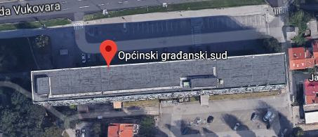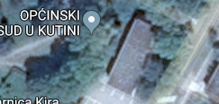

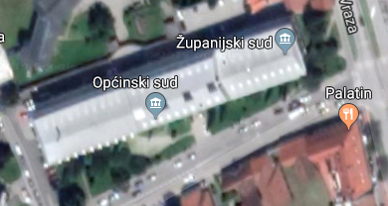

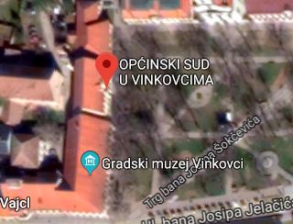
The building of the Municipal Court in Vinkovci is semi-detached. Since all the necessary certificates for starting works have been obtained, the neighbouring buildings cannot in any way jeopardize the once started works and vice versa. After the commencement of work is reported to the competent local authority and during the opening coordination meetings, the MoJ informs all natural persons and legal entities about the planned activities.

Energy renewal and renovation of the Municipal Court in Kutina

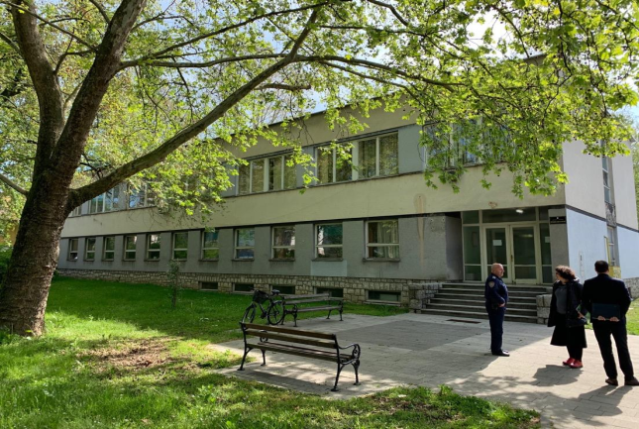
At present, most of the buildings within the judicial network do not meet the requirements defined and set by the Technical Regulation on Rational Use of Energy and Thermal Protection in Buildings (OG 128/15, 70/18 and 73/18). The Kutina Municipal Court building is one of the facilities in the judiciary that is characterized by unreasonable and high energy consumption. The goal of implementing measures and conducting works defined by the energy renovation project (ZOP eNu_2018-006) is to realize energy efficiency gains of the court building by improving working conditions.
Currently, energy efficiency works are underway and complete interior furnishing of the building is planned. It is to be noted that the municipal court building has already secured access and conditions for people with physical disabilities (lifting platform and toilet provided).
The target group of the planned energy renewal and renovation works are 48 judicial officials and civil servants of the Municipal Court in Kutina – judges, state attorneys and deputies of state attorneys, civil servants and other employees in judicial bodies of the MoJ and 52.260 residents of Kutina town regardless of their age, gender, nationality, religion, physical disabilities, sexual orientation, race or ethnicity.
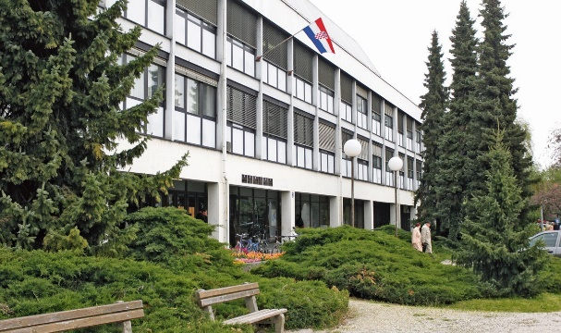
Renovation, adaptation and building upgrade of the County Court in Varaždin
The County Court in Varaždin is the fourth largest court in the Republic of Croatia. The court building was built in 1963 and as such it does not meet the increased needs for the working space and is technologically outdated.
Since the Court building is in the historic city centre, the Ministry of Justice – in cooperation with the architect who designed the building – initiated the process of changing Urban Design Plan of the historic centre of the city of Varaždin to allow a new building extension of the County Court. The procedure has been satisfactorily completed and the Conservation Office (CO) approved the proposed design solution.
The approved design is related to the construction of an additional floor of the existing building of the County Court in Varaždin. Also, a complete renovation which includes the installation of an elevator, improvements to toilet facilities for the disabled people.
Renovation and adaptation of the Municipal Court in Vinkovci
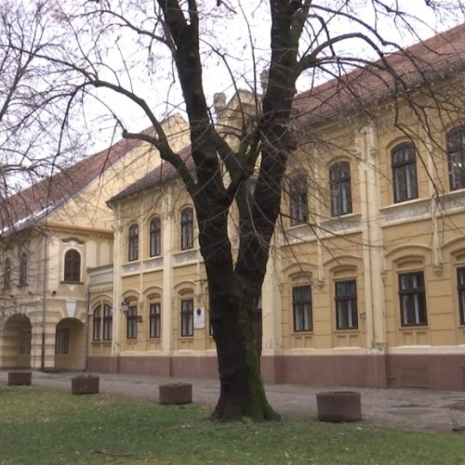
The building of the Municipal Court in Vinkovci is built over 150 years ago. It is protected as a cultural heritage monument and subject to fulfilling of conservatory requirements. The objective of the project is to preserve the cultural heritage, increase office space to accommodate more judges’ chambers, streamline court registries and records for better work organization and access by users, and improve energy efficiency and access for people with reduced mobility.
For the Municipal Court in Vinkovci, preparation and development of design documentation is underway to be followed by issuance of necessary permits. A complete renewal of the existing building is planned with a focus on the attic, which is currently not operational but intended to be put in function after renovation and adaptation. Also, the installation of an elevator will be undertaken.
Renovation and adaptation of the Municipal Court in Zagreb
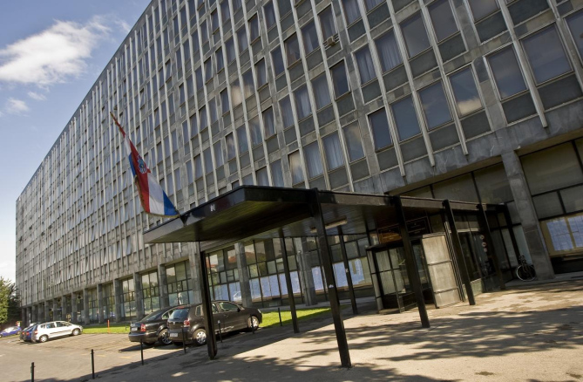
The building of the “Palace of Justice” in Zagreb is located in a wider city area and it is protected cultural good. Renovation works can be undertaken only under special conditions and prior approval of the conservative profession (Conservation Guidelines, Class: 612-08 / 17-005 / 771, Reg. No: 251-18-02-17-2 of 16 January 2017). It is to be noted that all required conservation permits have been duly obtained.
The building is in a dire need for renovation; facade is in poor condition; part of the wooden elements that carry the limestone lining has been torn; the sheets have rippled, the steel rolled profiles in the verticals have corroded; all reinforced-concrete parts of the structure (thermal bridges) are coated with stone; the windows are tilting and flaps and frames are covered with aluminium profiles and the roof is finished with bitumen foam. Also, a thermal protection does not meet necessary standards of the Technical Regulation on Rational Use of Energy and Thermal Protection in Buildings (OG 128/15, 70/18, 73/18).
Given the poor condition of the building, a complete renovation is planned. Renovation works include the restoration of the facades of the building, the roof, the boulders, fire safety construction elements and the joinery. In its existing condition, the Municipal Court in Zagreb has an elevator to enable access for people with reduced mobility, but additional improvements and measures will be carried out.

POTENTIAL ENVIRONMENTAL AND SOCIAL RISKS AND IMPACTS OF CIVIL WORKS

Environmental risk and impact
The project environmental risk is assessed as moderate and it is predominately linked to rehabilitation of four existing court buildings. Given that these are general and small-scale construction activities, the potential adverse risks and impacts on human populations and/or the environment are not likely to be significant. This is because the project activities are neither complex nor large, do not involve activities that have a high potential for harming people or the environment, and all of the project sites are located away from environmentally or socially sensitive areas. As such, the potential risks and impacts are (i) predictable and expected to be temporary and/or reversible; (ii) low in magnitude; (iii) site-specific, without likelihood of impacts beyond the actual footprint of the project; and have (iv) low probability of serious adverse effects to human health and/or the environment. These impacts most commonly include: a) dust and noise due to excavation, demolition and construction; b) management of demolition / construction wastes and accidental spillage of machine oil, lubricants, etc.; c) possible management of small amount of hazardous materials and waste like asbestos or paints and varnishes; d) traffic disturbance; e) small scale surface or ground water pollution; f) soil pollution or erosion; g) workers safety; and h) on cultural heritage sites as two buildings to be rehabilitated under project are protected and in some cases, although quite unlikely cultural heritage chance finds. The project’s risks and impacts can be easily mitigated in a predictable manner.
No adverse impacts on biodiversity and habitats are expected. The project builds on the Bank’s previous and current engagement in the justice sector in Croatia. The implementation of site specific Environmental and Social Management Plan (ESMP) for four court buildings supported under Justice Sector Support Project (2009 – 2014), was satisfactory. No significant gap in the implementation of the mitigation measures defined in the ESMP and good construction practices implemented on the field were observed during project implementation. The capacity for managing and implementing construction activities is adequate in MoJ, nonetheless, it will be further built around Environmental and Social Framework (ESF) through the project preparation and implementation period.
Social risk and impact
The project social risk is assessed as moderate as the IPF Component – Strengthening Investment and Infrastructure Management and Rehabilitation of Judicial Facilities – will be site-specific (four defined locations of court buildings) with no impacts beyond the footprint of the existing court buildings. No land acquisition will be required, and the interior works are small in magnitude (energy efficiency upgrade; interior remodelling) and as such will have impacts that can be easily and predictably mitigated. Risk related to labour influx is minimal given the small-scale nature of interior works of judicial facilities. Regular operation and functioning of the four courts will remain during the planned works so the beneficiaries will have a continuous and uninterrupted access to judiciary services.

BRIEF SUMMARY OF PREVIOUS STAKEHOLDER ENGAGEMENT ACTIVITIES TO DATE

Some preliminary stakeholder engagement activities have already been initiated, focusing on three main stakeholder groups:
- court users, who have expressed needs for improved reception areas/entrances;
- judges, who have expressed the need for improved office space (currently it can happen that 3 to 4 judges are sharing one office) and raised the issue of shortage of courtrooms to hold open trials and conduct other court proceedings.
- city mayors, of the municipalities in which the court buildings are located.

STAKEHOLDER IDENTIFICATION AND ANALYSIS
With support from the World Bank (WB), the MoJ has prepared a SEP and will implement it to ensure that stakeholder engagement is conducted on the basis of timely, relevant, understandable, and accessible information. The MoJ will ensure that both the format and location of the consultations are inclusive and accessible.
The SEP includes a Grievance Redress Mechanism (GRM) which will allow stakeholders, beneficiaries, and employees working on the project to review and provide their views on the information related to planned renovation works and raise any potential concerns.
Stakeholder identification
The first step in the SEP is to identify the key stakeholders to be consulted and involved. To define a communication process with the stakeholders, several groups that may be interested and/or affected by the project implementation have been identified. In particular, for this project, stakeholders include government authorities, users of judicial services, local authorities (mayors and city council members) and companies which will directly or indirectly benefit from the project.
The initial list of stakeholders is categorized under the following stakeholder groups:
Affected Parties
- Judicial staff, including judges, state attorneys, deputies of state attorneys, civil servants, employees and prosecutors working in the municipal and county courts selected;
- External users of the court services (citizens, businesses and lawyers representing their clients), including people with physical disabilities, residing in the four cities selected under the project;
- Inhabitants of neighbouring buildings who may be impacted by the construction works (e.g., dust, noise, traffic disturbances).
The table below captures the size of the population covered by the respective courts, the number of staff and the number of cases received in each court.
Table 1. Size of the population covered by the courts
 | Population covered by the court | Number of staff | Number of cases received by end of June 2019
Municipal Court in Kutina | 52,260 inhabitants | 48 officials and civil servants | 6,053 cases
County Court in Varaždin | 371,282 inhabitants | 58 officials and civil servants | 3,574 cases
Municipal Court in Vinkovci | 125,466 inhabitants | 100 officials and civil servants | 12,248 cases
Municipal Court in Zagreb | 590,820 inhabitants | 626 officials and civil servants | 70,688 cases
Source: Law on Areas and Seats of the Courts (OG 67/2018) and Central Bureau of Statistics (Census 2011)

Other interested parties
- Local government officials: mayors and city council members;
- The Ministry of Culture and its Cultural heritage bodies, i.e. the conservation institutions that issue permits and special conditions for specific construction requirements;
- Local and national media channels in Kutina (radio: Radio Moslavina; newspapers: Moslavački list; TV: Kanal KT), Varaždin (radio: Radio Varaždin; newspapers: Varaždinski list; TV: VTV – Varaždinska televizija), Vinkovci (radio: Radio Vinkovci; newspapers: Vinkovački list; TV: Plava vinkovačka televizija) and Zagreb (HRT – Croatian Radio and Television).

The following internal stakeholders can also be included in the category of “other interested parties”:
- The Ministry of Justice, as implementing agency;
- Parties involved in construction activities: Contractors, OHS specialist, Supervision engineer, Designer, Design auditor.

Disadvantaged / vulnerable individual or groups

The objective of the project to upgrade judicial infrastructure and improve access to judicial services and quality infrastructure will equally benefit Croatian citizens residing in the four cities regardless of race or ethnicity or skin colour, gender, language, religion, political or other beliefs, national or social background, property status, union membership, education, social status, marital or family status, age, health status, disability, genetic inheritance, gender identity, expression or sexual orientation, all in accordance with the Anti-Discrimination Act (OG 85/08, 112/12).

One vulnerable group which will benefit particularly from the project are people with reduced mobility, as per the below table.

Table 2. Project-related activities with potential impact on vulnerable groups

 | Existing and planned accessibility features for people with reduced mobility | Impact of the project
Municipal court in Kutina | The municipal court building has already secured access and conditions for people with reduced mobility (lifting platform and toilet provided). | No major change
Municipal court in Zagreb | In its existing condition, the Municipal Court in Zagreb has an elevator to enable access for people with reduced mobility, but additional improvements and measures will be carried out. | Greater accessibility for people with reduced mobility
Municipal court in Vinkovci | The installation of an elevator will be undertaken.
County court in Varaždin | A complete renovation which includes the installation of an elevator, improvements to toilet facilities for people with reduced mobility.

Table 2 below presents the key stakeholder groups relevant to the project.

Table 3. List of project stakeholders

Stakeholder | Stake/nature of interest in the project | Interest | Influence
Project-affected parties
Judicial staff | - Interested in the successful completion of the project, as it will lead to major improvements of their working conditions  - Possible concerns may be linked to delays in the construction/rehabilitation works and disruptions to their work | High | High
Court users | - Interested in the successful completion of the project, as it will lead to greater efficiency of the courts and modernized facilities which provide greater comfort and better accessibility  - Possible concerns may be linked to temporary traffic disturbances linked to the reconstruction works and other negative impacts (e.g., dust, noise) | Medium | Medium
Court users with reduced mobility | - Interested in the successful completion of the project, as the renovations will be undertaken to improve accessibility according to principle of universal access | High | Low
Inhabitants of neighbouring buildings | - Potentially affected by the construction works (e.g. noise, dust, traffic disturbances) | Medium | Medium
Other interested parties
Ministry of Culture  Conservation Department in Vukovar | - Interested in the cultural preservation of the court buildings  - Issued special conditions for the protection of immovable cultural heritage regarding the Municipal Court in Vinkovci | High | High
Ministry of Culture, Directorate for the Protection of Cultural Heritage | - Interested in the cultural preservation of the court buildings  - Determined that the building of the Municipal Court in Zagreb is a cultural good | High | High
Local authorities: Mayors and city council members of Kutina, Varaždin, Vinkovci, and Zagreb | - Interested in the successful completion of the project, as it will lead to greater efficiency of the courts and modernized facilities  - Will be involved in monitoring of project progress and discussions surrounding most project activities | Medium | Low
Local and national media | - Will inform the interested public about project activities | High | Medium
Internal stakeholders
MoJ Project Implementation Unit | - The Department for Strategic Development and Projects within the Directorate for Strategic Development, Informatization and Capital Investments in the Judiciary is responsible for all stakeholder engagement activities and ultimately the improvement of court infrastructure, equipment and operations | High | High
Contractor | - Will execute construction in conformity with the building permit, the Building Act, technical regulations, special regulations, code of practice, etc. | High | High
Designer | - Is responsible for ensuring that the designs developed comply with the prescribed requirements and in particular that the designed construction work is in conformity with the location permit or the requirements for construction works prescribed by the spatial plan, and that it complies with requirements prescribed for the energy efficiency performance of buildings | High | High
Principal supervising engineer | - Is responsible for the completeness and coordination of the building surveillance and for drawing up a final report thereof | High | High
Design auditor | - Is responsible that a design or part of a design that he audited and gave a favourable report thereon, complies with the requirements of the Building Act, special acts and regulations adopted on the basis of those acts, technical specifications and the code of practice regarding a characteristic audited. | High | High
Occupational health and safety (OHS) specialist | - The work in a safe manner is drafted and signed by the occupational health and safety specialist | Medium | Medium

Table 4. Matrix of the stakeholders level of influence and level of interest
Level of Influence
High |  |  | MoJ; County Court in Varaždin;  Municipal Courts in Kutina, Vinkovci and Zagreb;  MoC, Conservation Department in Vukovar; MoC, Directorate for the Protection of Cultural Heritage;  Designer; Contractor; Principal supervising engineer; Design auditor
Medium |  | Occupational health and safety specialist;  Users of judicial services | Local and national media
Low |  | Local authorities | People with reduced mobility
 | Low | Medium | High | Level of Interest

Color-coding | Engage closely and influence actively:  require regular and frequent engagement, typically face-to-face and several times per year, including written and verbal information
Keep informed and satisfied:
require regular engagement (e.g. every half-a-year), typically through written information
Monitor:
require infrequent engagement (e.g. once a year), typically through indirect written information (e.g. mass media).

STAKEHOLDER ENGAGEMENT PROGRAM

Purpose and timing of stakeholder engagement program

Stakeholder engagement activities need to provide specific stakeholder groups with relevant information and opportunities to voice their views on topics that matter to them. The table below presents the stakeholder engagement activities envisaged under the project. The activity types and their frequency are adapted to the three main project stages (preparation; implementation/construction; post-construction).

Table 5. Stakeholder engagement activities

Project stage | Target stakeholders | Topic(s) of engagement | Methods used | Location/  Frequency | Responsibilities
Preparation (prior to the commencement of works) | Local authorities; Management staff of the judicial bodies | Present project information and planned activities: scope, rationale, E&S principles, envisaged timeframes; Coordination mechanisms; ESMP checklist; Grievance mechanism | In-person “opening coordination meetings” in each locality; phone and email communication | At least one month prior to start of construction works | PIU staff and  Contractor
Implementation/construction | Management staff of the judicial bodies; judicial staff | Present project information and progress updates; potential difficulties in implementation and any deviations from the timetables | In-person meetings | At least one monthly meeting in each court; and other meetings as needed | PIU Project Manager; Contractor; Supervision engineer
 | Court users; judicial staff | Present project information and progress updates; Disclose all relevant project documentation | MoJ website; bulletin boards of judicial buildings; posters | Monthly | PIU Project Manager
 | Local and national media | Present project information and progress updates | Press releases | One week prior to the start and one week following the end of construction works for each building | PIU Project Manager
 | Neighbouring buildings inhabitants | Parking restrictions; Traffic safety; Grievance Redress Mechanism | Posters; signs; banners | On-site during construction works | Contractor
Post-construction | Management staff of the judicial bodies | Satisfaction with building rehabilitation | Phone and email communication | One month after end of construction works | PIU Project Manager

Also, a broader citizen engagement activities will be mainstreamed across the project. Consultations with robust feedback mechanisms will be carried out consistently throughout project implementation, both for the results-based component as well as for the component on rehabilitation and renovation of selected court facilities. Regular consultations (at least four focus groups with businesses throughout project implementation) will inform the simplification of business regulations that affect business entry and operation, as well as the automation of government to business services. In the courts, regular consultations with judges and court staff will be used to continuously monitor and improve the quality and efficiency of justice service delivery, as well as to strengthen the design and build ownership of the rehabilitation of the four selected court facilities. In addition, surveys will be conducted to measure satisfaction of businesses and users of court services with the on-site and e-services supported under this project. User survey results will be discussed during the outreach events (at least one open day in each of the selected court facilities), corrective actions will be taken and impact will be assessed at project closing.

RESOURCES AND RESPONSIBILITIES FOR IMPLEMENTING STAKEHOLDER ENGAGEMENT ACTIVITIES

The MoJ’s project preparation service (Project Implementation Unit – PIU), which operates under the structure of the Department for Strategic Development and Projects within the Directorate for Strategic Development, Informatization and Capital Investments in the Judiciary, is the core stakeholder of the project. Its role is to assist in the development and delivery of a full range of effective internal and external strategic stakeholder engagement activities in order to effectively translate departments’ goals into specific organizational outcomes.
It is planned to set up a temporary information board on the building undergoing renovation (at the site of renovation) but also at the MoJ. The MoJ plans to report on all key steps in the implementation of infrastructure projects financed through the World Bank loan to the general public through its website. All stakeholder engagement activities mentioned in table above will be financed by MoJ’s own budget and/or project funds.
Responsibilities for stakeholder engagement activities will be defined through Terms of Reference for PIU Staff for which procurement will be conducted (it is very likely that Project Manager will be mainly responsible for the SEP implementation, but this will be further discussed and agreed during project negotiations). However, the MoJ will play an active role in stakeholder engagement activities.

INFORMATION DISCLOSURE

The MoJ will disclose project information to allow stakeholders to understand the risks and impacts of the project, and potential opportunities. Stakeholder engagement depends on timely, accurate, accessible, and comprehensible information. Making available project-related information as early as possible is important.
Site-specific Environmental and Social Management Plan (ESMP) checklists proposed to tackle typical mitigation approaches to common civil works contracts with localized impacts will be disclosed. Given that location of court buildings is known, and design is prepared for three of those, the MoJ will prepare three site specific ESMP checklists prior to appraisal. As the project might support preparation of design for the Varaždin building, ESMP checklist for the Varaždin court will be prepared during project implementation but in advance of construction activities. Project Environmental and Social Commitment Plan (ESCP) will indicate timeline, responsibility and due diligence for the Varaždin ESMP checklist.
The site-specific documents will constitute an integral part of bidding documents for contractors. Site specific ESMP checklist will be timely disclosed and discussed with public. Special condition for construction and mitigation measures are being issued by cultural heritage protection departments in Zagreb, Varaždin and Vukovar (for Vinkovci building), relative to the status of protection. The ESMP checklist will have a site-specific annex that will identify cultural protection measures and monitoring. It will also provide specific guidance on workers’ occupational, health and safety measures and inclusive of safety measures for the judges, civil servants, employees and visitors during the implementation of works as in some cases rehabilitation activities might be carried out in parallel with the regular court operation activities.
Prior to the project appraisal planned for fourth quarter of 2019, the following documents will be prepared and disclosed:
- Environmental and Social Plan Checklist (ESMP Checklist) for courts in Vinkovci, Zagreb, Varaždin and Kutina;

- Labour Management Procedure (LMP) for project workers;

c) Stakeholder Engagement Plan (SEP)

Documentation and information on updates from the project activities and the result of consultation with stakeholders will be disclosed by PIU throughout next information dissemination channels:
- MoJ’s website → https://pravosudje.gov.hr/.
- Local and national media → Kutina (radio: Radio Moslavina; newspapers: Moslavački list; TV: Kanal KT), Varaždin (radio: Radio Varaždin; newspapers: Varaždinski list; TV: VTV – Varaždinska televizija), Vinkovci (radio: Radio Vinkovci; newspapers: Vinkovački list; TV: Plava vinkovačka televizija), Zagreb (HRT – Croatian Radio and Television).
- Bulletin boards of judicial buildings

Consultation schedule
Based on the readiness of the project approval and concerning the nature of the construction works, the exact schedule of the project activities and consultations will be specified and published one month before the start of the construction works. As mentioned above, future stakeholder meetings will also be agreed upon and communicated subsequently.
MONITORING AND REPORTING
A detailed monitoring and reporting plan for each location is envisaged. To ensure successful, on-site weekly meetings (between engineer, Contractor and Users’ representatives) and monthly meetings (between all stakeholders in the project) will be organised. Engineer is obliged to write minutes from the held monthly meetings and distribute it to all stakeholders on conformation. The monitoring of implementation implies constant communication with the Contractor, End User (representatives of the Courts - usually Court Presidents) and the Supervising Engineer; the control of reports submitted by the Supervising Engineer and on-the-spot checks. MOJ’s PIU will conduct on-the-spot checks in all stages of the project (ad hoc or related to the payments). Representative of MOJ’s PIU is obliged to participate in regular monthly meetings in which progress of the works in the past month will be monitored, potential difficulties in implementation and any deviations from the timetables discussed (in reference to the planned works in the future).
During the implementation of the contract, it is possible to hold additional ad hoc meetings (regardless of the party organizing it) at which the MoJ’s PIU is required to participate depending on the assessment, to monitor the implementation and to resolve possible difficulties related to the implementation of the contract.
The supervising engineer has a contractual obligation to submit reports informing the MOJ’s PIU and the affiliate institution of the status and all elements of the implementation of the works contract, including potential difficulties. The reports to which the Supervising Engineer directly provides information on the implementation of public works contracts are
a) Initial report
b) Monthly reports

The initial report shall be submitted to the MOJ’s PIU and the End Users within one month after the start of the implementation of the professional supervision contract and shall include analysis and comments on the project documentation and the public works contract, identification of possible problems, assessment and proposal of the organization of the professional supervision implementation and various other information as needed. Upon receiving the consent of the End Users MoJ’s PIU will issue a formal approval of the report submitted.
The Supervisory Engineer's monthly reports are submitted no later than 2 days prior to the monthly meetings, describing the results achieved during the previous month, as well as a plan of expected activities for the next month. The reports should include at least 8 photographs from the construction site, the minutes of the supervising engineers from all meetings held, a summary of the Contractor's monthly report, a timetable for the work to be performed, and financial tables with analysis of payments, problems, changes, and possible solutions. The draft report is submitted by e-mail and commented by the MOJ’s PIU and the End User but is not subject to formal approval. The final version of the monthly report is submitted in paper form.
GRIEVANCE REDRESS MECHANISM
A Grievance Redress Mechanism (GRM) is a process for receiving, evaluating, and addressing project-related complaints, feedback, questions and suggestions from citizens and affected communities at the level of the project.
The mechanism focuses not only on receiving and recording complaints but also on resolving them. While feedback should be handled at the level closest to the complaint, all complaints should be registered and will follow the required procedures.
Key definitions of grievance and complaint are as follows:
→ Complaint: an expression of dissatisfaction that is related to an impact caused by a project activity, which has affected an individual or group. Adversely, the interests of an individual or group and the individual or group want a proponent or operator (or contractor) to address and resolve it (e. g. problems related to dust deposition, noise or vibration). A complaint is normally of a less serious nature than a grievance;
→ Grievance: a claim raised by an individual or group whose livelihood, health and safety, cultural norms and heritage are considered to have been adversely affected by a project activity which, if not addressed effectively, may pose a risk to operations (through stakeholder actions such as access road blockages) and the livelihood, well-being or quality of life of the claimant(s). The grievance mechanism described in this section includes both complaints and grievances.
Objectives of the project-based GRM
The project-based GRM is intended to serve as a mechanism to:
• Allow for the identification and impartial, timely and effective resolution of issues affecting the project;
• Strengthen accountability to beneficiaries, including project-affected people, and provide channels for project stakeholders and citizens at all levels to provide feedback and raise concerns.
Having an effective GRM in place will also serve the objectives of: reducing conflicts and risks such as external interference, corruption, social exclusion or mismanagement; improving the quality of project activities and results; and serving as an important feedback and learning mechanism for project management regarding the strengths and weaknesses of project procedures and implementation processes.
GRM overview and structure
The GRM will be accessible to a broad range of project stakeholders who are likely to be affected directly or indirectly by the project. These may include internal justice sector operators (judges, staff, prosecutors, etc.) as well as external users (citizens, businesses and lawyers representing their clients), other beneficiaries, community members, project implementers/contractors, civil society, media – all of who will be encouraged to refer their grievances and feedback to the GRM. The GRM can be used to submit complaints, feedback, queries, suggestions or compliments related to the overall management and implementation of the project activities. The GRM’s functions will be based on the principles of transparency, accessibility, inclusiveness, fairness and impartiality and responsiveness. It will establish clearly defined timelines for acknowledgement, update and final feedback to the complainant.
To enhance accountability, these timelines will be disseminated. The timeframe for acknowledging receipt of a feedback will not exceed 7 days from the time that it was originally received; if an issue is still pending by the end of 20 days the complainant will be provided with an update regarding the status of the grievance and the estimated time by which it will be resolved; and all grievances will be resolved within 30 days of receipt. The Project Implementation Unit (PIU) staff will be responsible for managing the GRM.
GRM scope and use
GRM will be available for project stakeholders and other interested parties to submit questions, comments, suggestions and/or complaints, or provide any form of feedback on all project activities. GRM’s users will be project beneficiaries, project-affected people (positively or negatively), as well as the broader citizenry. The GRM will be managed by a dedicated staff of the (PIU) staff under the direct responsibility of the Project Manager (PM). Complaints, suggestions, comments and any other issues can be submitted at any time throughout the project implementation.
MoJ’s complaint mechanisms practice
Under the project cycle management, the MoJ responds impartially and responsively to all complaints, whether they came from the users of judicial services, media, official state institutions, etc. Complaints and petitions can be submitted through a telephone exchange (+385 1 3714 000), e-mail (pitanja@pravosudje.hr) or on the MoJ’s website through the e-form via the following link:
https://pravosudje.gov.hr/pristup-informacijama-6341/ostale-informacije/predstavke-i-prituzbe/6200
Also, on-site information boards will include the contact details of the contractor (which name needs to be updated after contracting) and the MoJ’s, as well.
Afterward, technical services of the MoJ are receiving and addressing complaints to the Directorate for Organization of Judiciary – Unit for Complaints, which is the first point in charge of the examination of the complaint content.
After a proper formal response to the complaint is prepared, MoJ is obliged to respond to the interested party within a reasonable time.
In case the resolution of complaint or grievance has not been achieved, an appeals process against the decision of the authority of first instance is allowed in line with national legislation. The appeal concerned can be lodged within 15 days following the receipt of the decision. The central state administration authority responsible for justice affairs shall decide on the lodged appeal (MoJ of the Republic of Croatia). An administrative dispute may be instituted against the decision of the MoJ of the Republic of Croatia, as a second instance authority, before the Administrative Court (AC) of the Republic of Croatia, within 30 days following the receipt of the decision.
If the amicable settlement of any major dispute in implementation fails for any reason, the stakeholder may inform the other that it will seek a judicial settlement before the competent court.
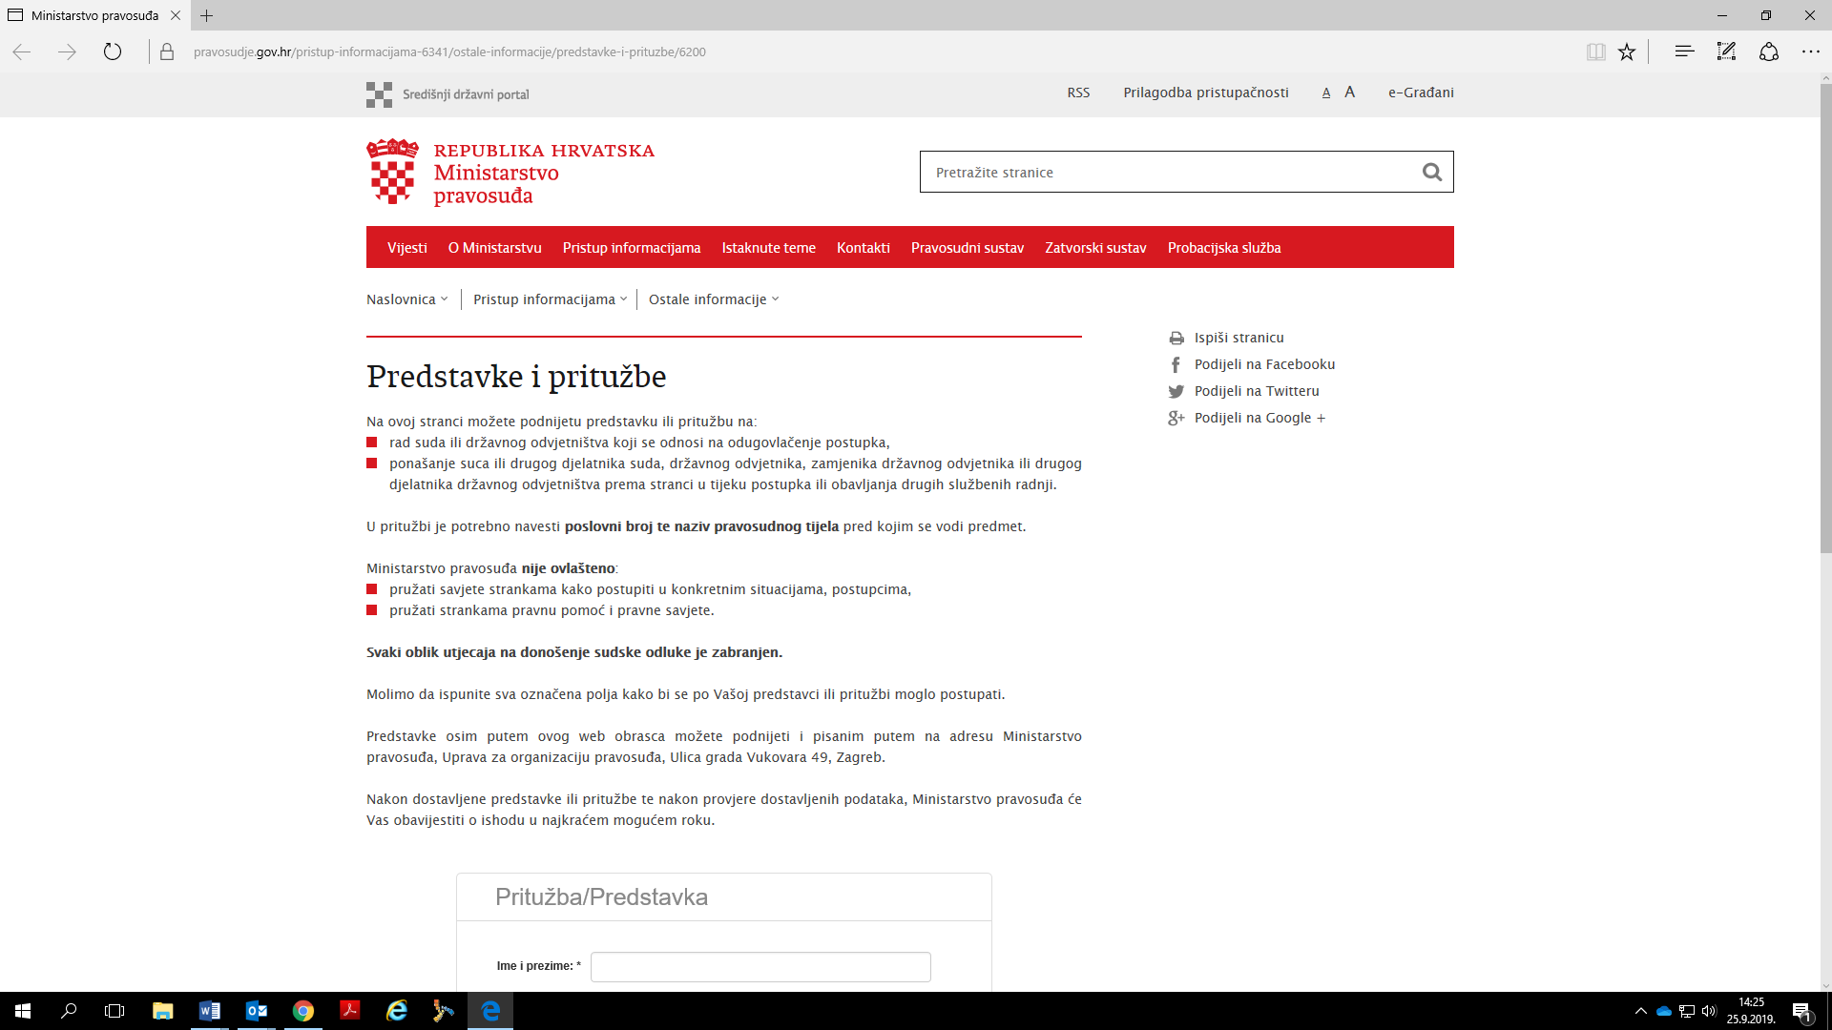

WB’s complaint mechanisms practice
Project stakeholders and citizens can also submit complaints regarding the project activities through the World Bank Grievance Redress Service (GRS). Communities and individuals who believe that they are adversely affected by a World Bank-supported project may submit complaints to existing project-level grievance-redress mechanism or to the WB’s (GRS). The GRS ensures that complaints received are promptly reviewed in order to address project-related concerns. Project-affected communities and individuals may submit their complaint to the WB’s independent Inspection Panel (IP), which determines whether harm occurred, or could occur, as a result of the WB noncompliance with its policies and procedures.
Complaints may be submitted at any time after concerns have been brought directly to the WB's attention, and Bank Management (BM) has been given an opportunity to respond. For information on how to submit complaints to the WB’s GRS, please visit: http://www.worldbank.org/en/projects-operations/products-and-services/grievance-redress-service.
For information on how to submit complaints to the WB’s Inspection Panel, please visit www.inspectionpanel.org.
Complaints management and dispute resolution systems within public procurement (PP)
Public procurement regulatory framework in Croatia establishes a transparent and effective complaints review mechanism. It is fully aligned with the good international practices in many aspects. According to Public Procurement Act authorized to solve disputes initiated by bidders that are stating their complaints is State's Commission for Control of Public Procurement Procedure, as an independent body. Parties involved in the complaint procedure are the appellant, client, applicant and bidder. During the procedure, the client is required to prove facts and circumstances which are base for his decision about bidder whose offer is accepted. On the other hand, appellant must prove breaches that have happened during procurement procedure or legal preconditions that haven't been met. According to the Public Procurement Act’s article 405. appeal must be submitted to State’s Commission for Control of Public Procurement Procedures (DKOM) in writing and delivered directly, through accredited post service provider or can be send electronically via connected informational system established between State’s Commission and Croatian Public Procurement Electronical Advertisement.
Public Procurement Act defines content of complaint (article 420.) mentioning information and documents that must be made available to the State’s Commission, like for example information on appellant (name, identification number, address, e-mail address, etc.), subject of complaint, evidence for his claim, proof that fee for starting complaint’s procedure has been payed, demand that appellant has, etc.
Complaints/appeals must be sent to State’s Commission in proper deadlines, also defined in Public Procurement Act (PPA). Basically, deadline is 10 days after certain different situations have happened according to different types of procurement procedures. Details regarding deadlines can be found in articles 406- 414 of PPA.
Once the State’s Commission receives complaint and complaint is sent according to deadlines and in format defined in PPA, the Commission is obliged to make its decision in 30 days, as is stated in article 432 paragraph 2 of PPA. Decisions on the appeals of the State Commission are published on their website daily basis. State's Commission is paying special attention on presumptions connected with deadlines to submit offer, to criteria which must be met, and other procedure conditions or breaches that might take place during procurement procedure.
Public Procurement Act defines exactly which information must be stated in complaint, as well as deadlines relevant for submitting complaint. After examining documents that must be part of complaint package, State's Commission can decline complaint, terminate agreement, order fine or bring any other measure according to public Procurement Act's provisions.
Regarding complaints in MoJ’s tenders, they are also resolved by DKOM in max. of 30 days (as described in the beginning of this section). Most often, complaints pertain to errors in tender documentation and award decision.
CONCLUSIONS
The SEP is a strategy development planning tool. It needs to be conducted in an efficient way so that its consultative processes and recommendations remain relevant to and can influence the on-going decision-making process. Through various measures SEP will seek to maximize stakeholder involvement in each phase of the process recognizing it as a strategic tool and will establish the framework and direction for future more intensive and site-specific consultations with a broader range of stakeholders as the basin development planning process moves forward.
The MoJ has experience in managing, coordinating and planning project activities, solving problems, making decisions, managing risks and human resources and reporting on the project. Given the context above mentioned and according to the Law on Construction (OG 153/13, 20/17, 39/19), MoJ is obliged to contract supervision of works to ensure technical and professional control of the project for the whole time of the execution of all planned infrastructure works of the courts in Kutina, Varaždin, Vinkovci and Zagreb. After finalizing the constructions, the main responsibility of monitoring will fall under the MoJ and selected judicial bodies.
The MoJ has the management capability and capacity as well as an experience to carry out this project. Long-standing experience in project preparation and implementation, whether it is project financed by EU funds or loans from international financial institutions such as the World Bank, is certainly the key to success.
In the future phases of the project, people will be kept informed as the project develops, including reporting on project environmental and social performance and implementation of the SEP and GRM. The project should report as often as possible to stakeholders, especially when the public may experience more impacts or phases are changing (reports during construction works, reports during the whole time of preparation and implementation of the project, etc).
The project will surely have positive impact on the promotion of equal opportunities, non-discrimination and universal access. The project target group will use the court buildings regardless of race or ethnicity or skin colour, gender, language, religion, political or other beliefs, national or social background, property status, union membership, education, social status, marital or family status, age, health status, disability, genetic inheritance, gender identity, expression or sexual orientation, all in accordance with the Anti-Discrimination Act (OG 85/08, 112/12).
The project will ensure the promotion of equal opportunities and social inclusion of the local population in terms of access to information on the project, its activities and benefits, World Bank co-financing and steps that can be taken to reduce energy consumption in daily life.

According to the existing Law on Areas and Seats of the Courts (OG 67/2018) and available data on the population of the Central Bureau of Statistics (Census 2011), the Municipal Court in Kutina covers 52,260 inhabitants. Until the end of June 2019, the Municipal Court received 6,053 cases.
According to the existing Law on Areas and Seats of the Courts (OG 67/2018) and available data on the population of the Central Bureau of Statistics (Census 2011), the County Court in Varaždin covers 371,282 inhabitants. 58 officials and civil servants work in the County Court in Varaždin daily. Until the end of June 2019, the County Court received 3,574 cases.
According to the existing Law on Areas and Seats of the Courts (OG 67/2018) and available data on the population of the Central Bureau of Statistics (Census 2011), the Municipal Court in Vinkovci covers 125,466 inhabitants. 100 officials and civil servants work in the Municipal Court in Vinkovci daily. Until the end of June 2019, the Municipal Court received 12,248 cases.
According to the existing Law on Areas and Seats of the Courts (OG 67/2018) and available data on the population of the Central Bureau of Statistics (Census 2011), the Municipal Court in Zagreb covers 590,820 inhabitants. 626 officials and civil servants work in the Municipal Court in Zagreb daily. Until the end of June 2019, the Municipal Court received 70,688 cases.
According to the Building Act (OG 153/13, 20/17, 39/19) and the Occupational Health and Safety Act (OG 71/14, 118/14, 154/14, 94/18, 96/18); see Table 1.
Usually Court Presidents.
As in: https://pravosudje.gov.hr/vijesti/novi-projekti-energetske-obnove-pravosudnih-i-kaznenih-tijela/21370 (16.09.2019.)

